Exercise 1:
The LED will turn on when both of the inputs are activated, or the output generates a value of 1.
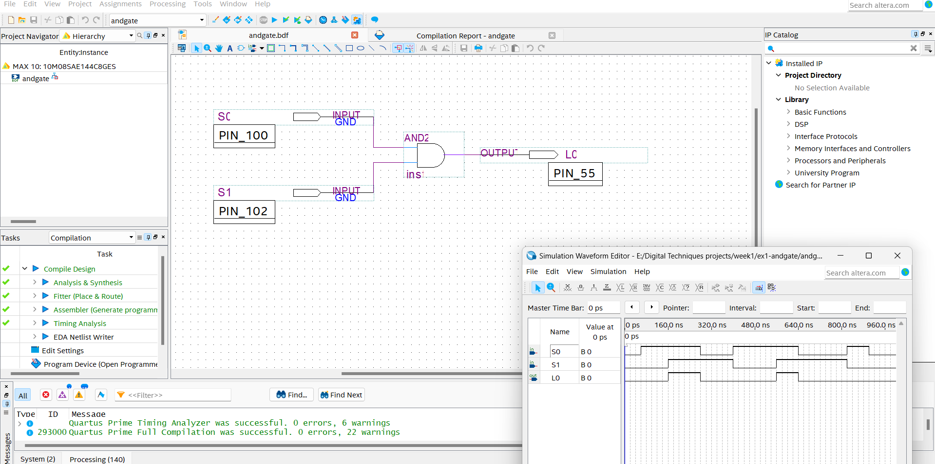

Exercise 2:
- Truth table:
a | b | L
0 | 0 | 0
0 | 1 | 1
1 | 0 | 1
1 | 1 | 0

- A diagram with the results of simulation:
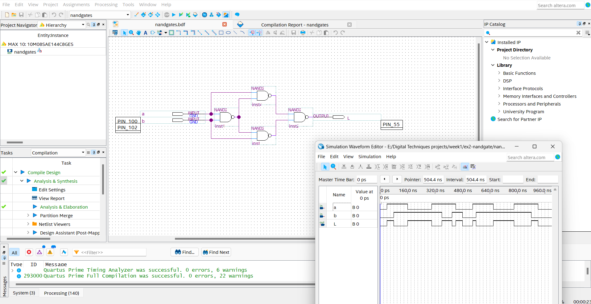

- Which logical operator is realized by the circuit you’ve just built? -> It’s EXOR logical operator.

